**Managing Talent**

<https://www.coursera.org/learn/managing-talent/home/welcome>

**Week 1**

First step is to have a strategy when hiring a talent, the most important thing is to have in mind what is expected of the value to be created by the talent that is being hired.

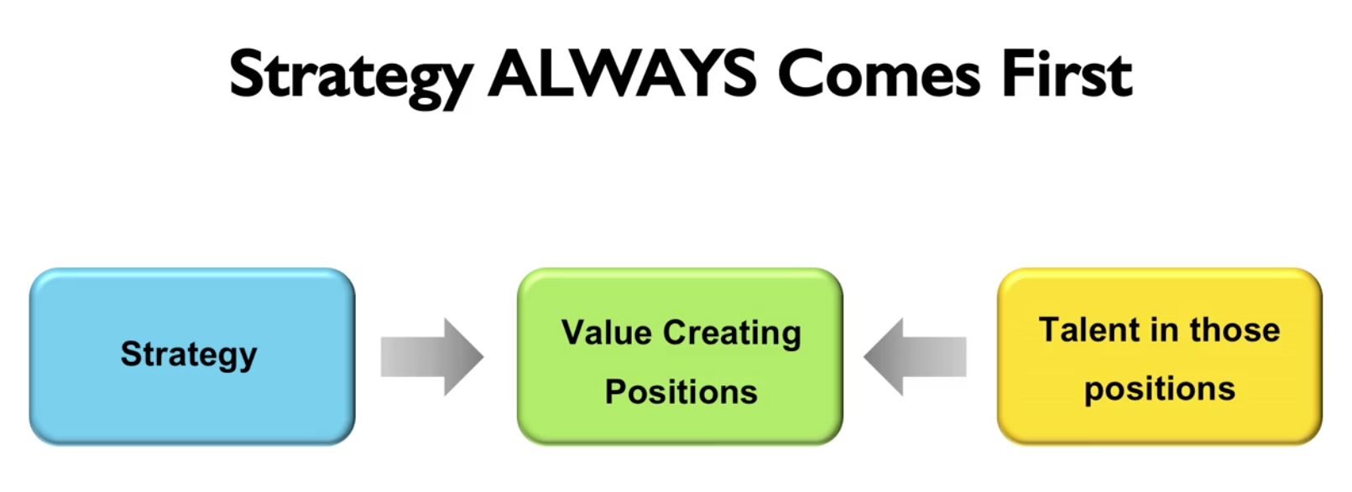

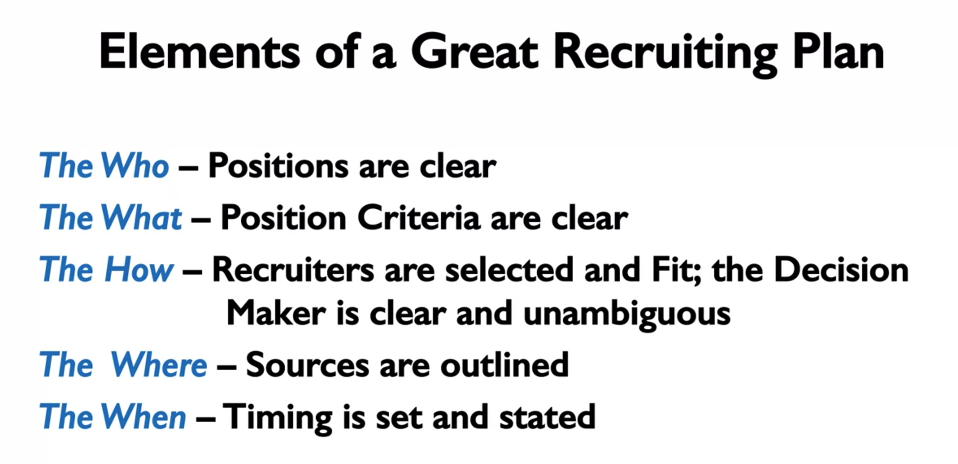

The best way of selecting talents is behavioral interviewing, that is paying attention to the candidate, how they behave, talk and express themselves.

Good questions:

* What have you learned in your last position?
* When have you failed? What have you done about it? (to fix it)

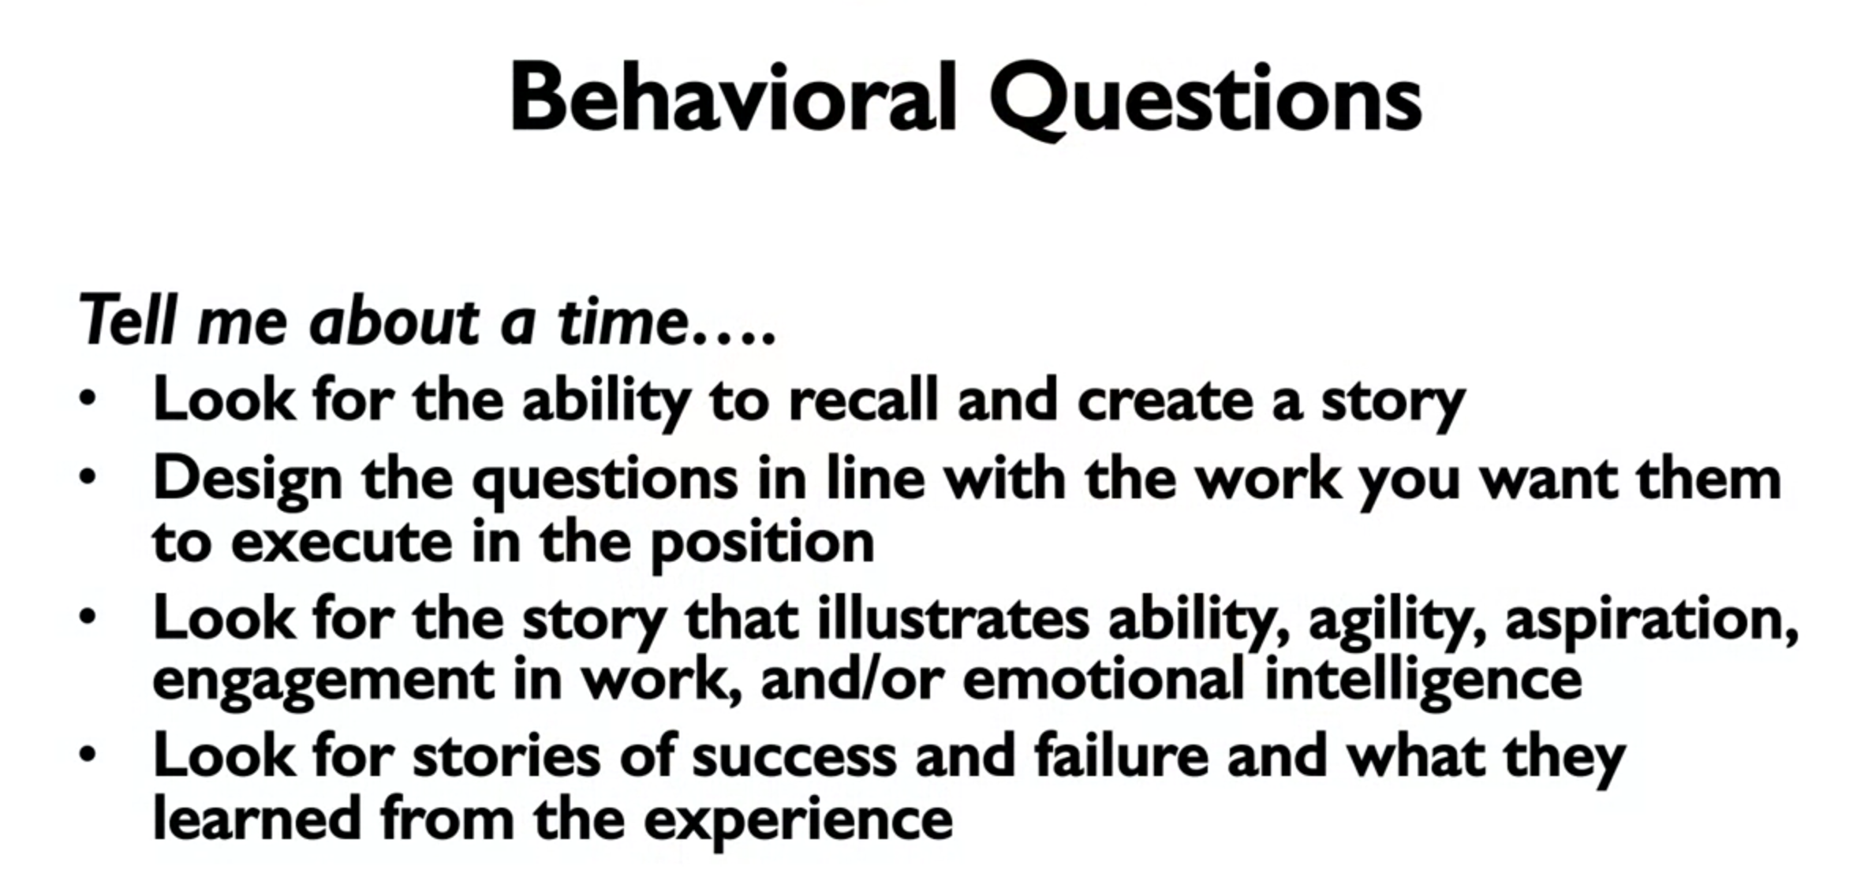

**Week 2**

We tend to have the perception that we are better than we actually are, we tend to be optimistic about how good we are.

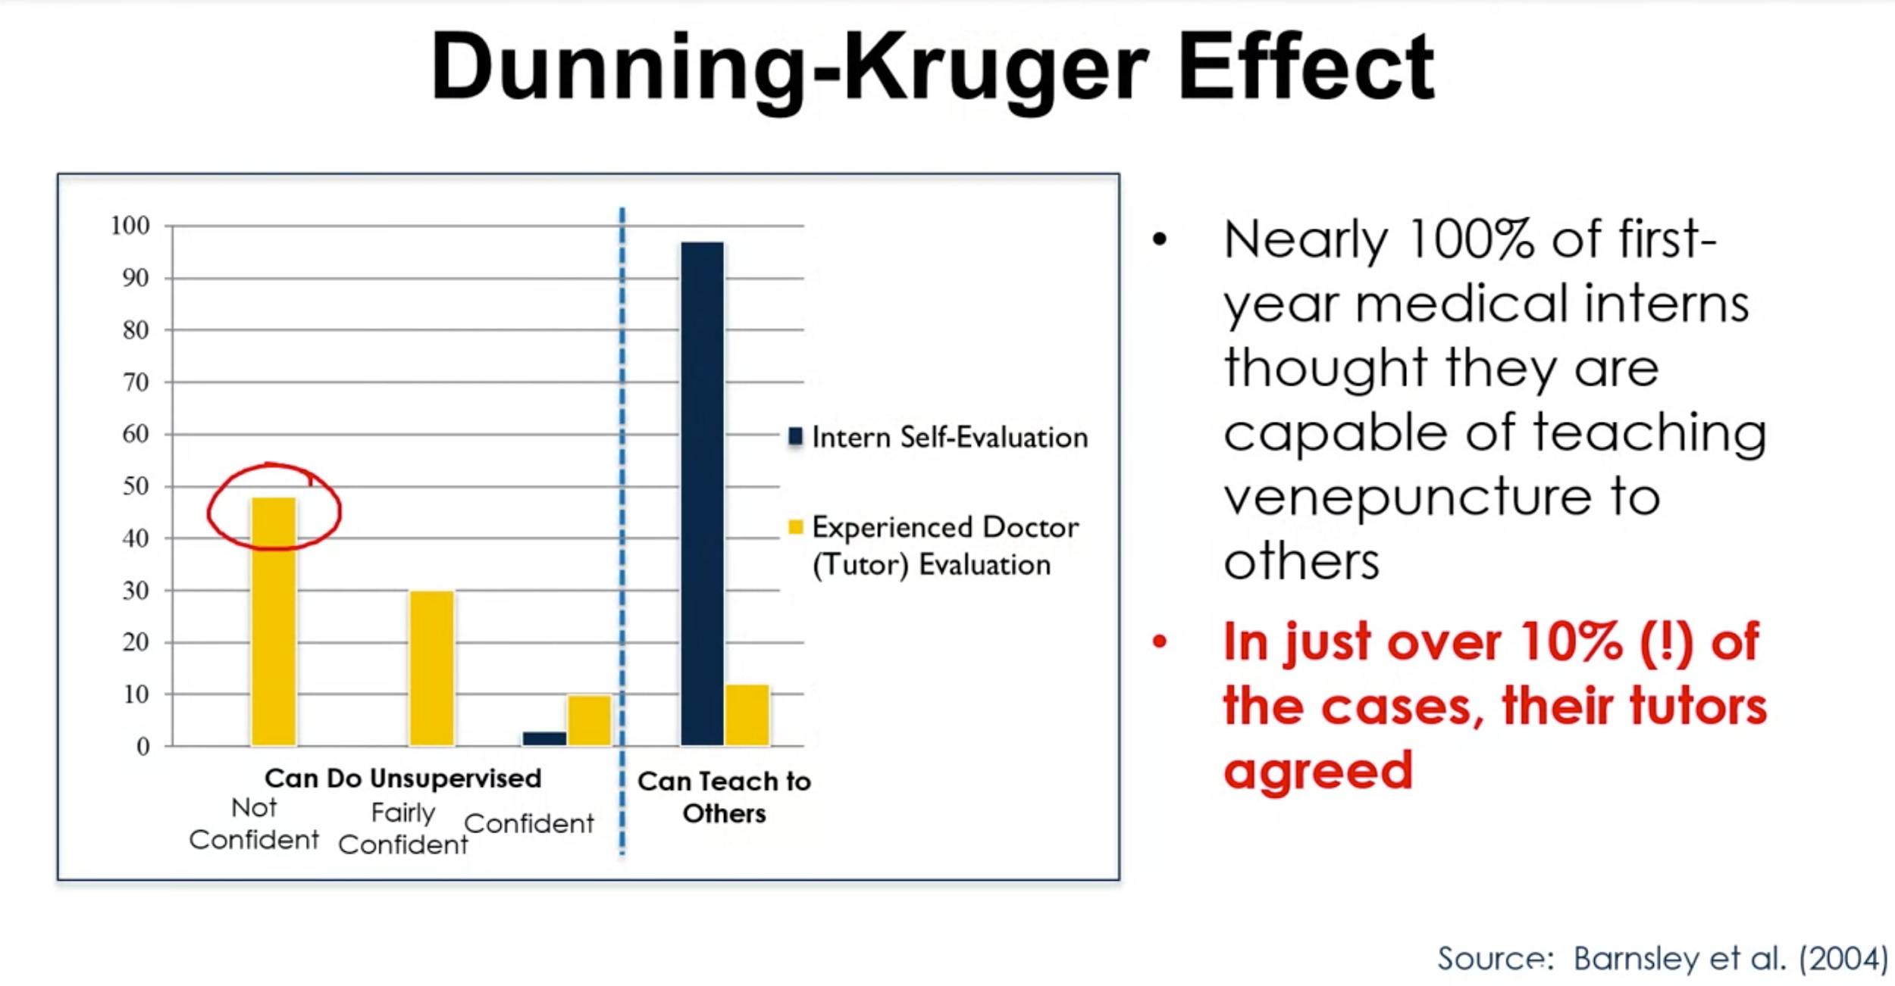

Regarding the ways of measuring performance, we have forced and non-forced distributions (for example, lower 10% will be bad performance, higher 20% will be good performance, the rest is median performance).

For the forced distribution it was noted an increase of 8% in the average performance of the distribution followed by a decrease in the average performance.

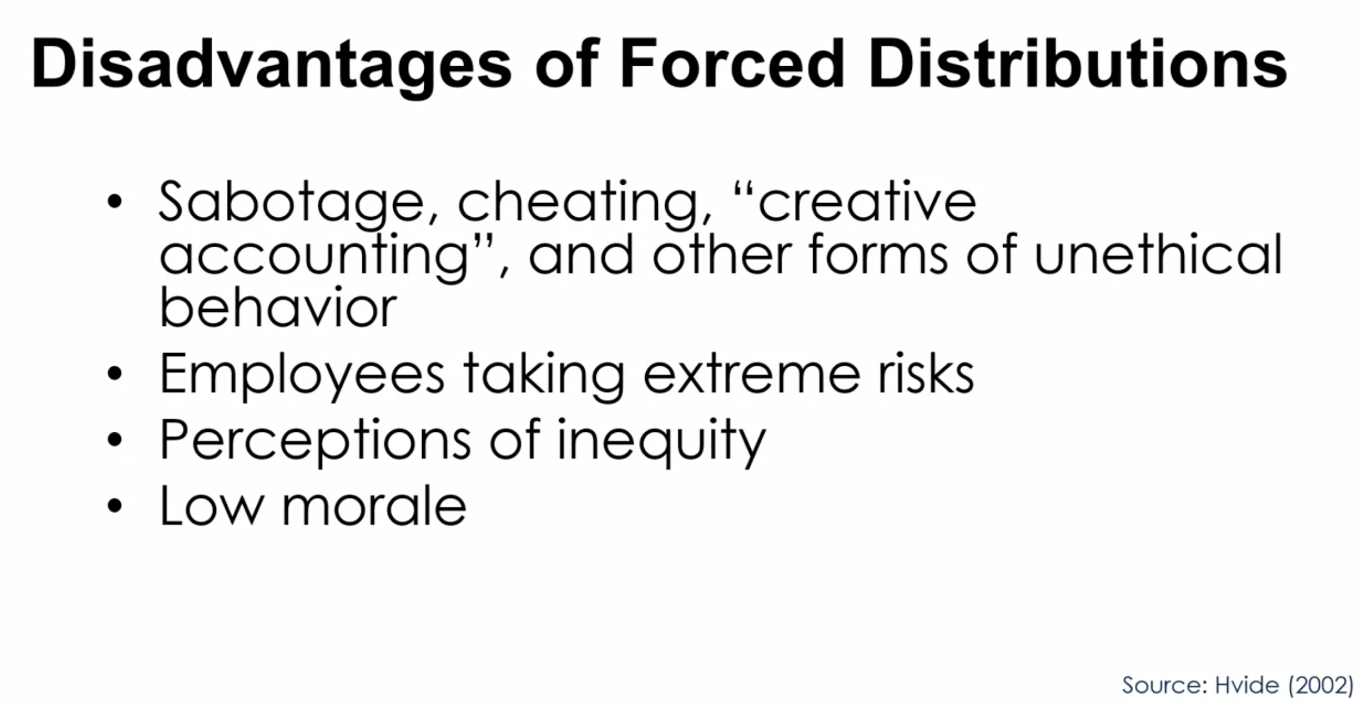

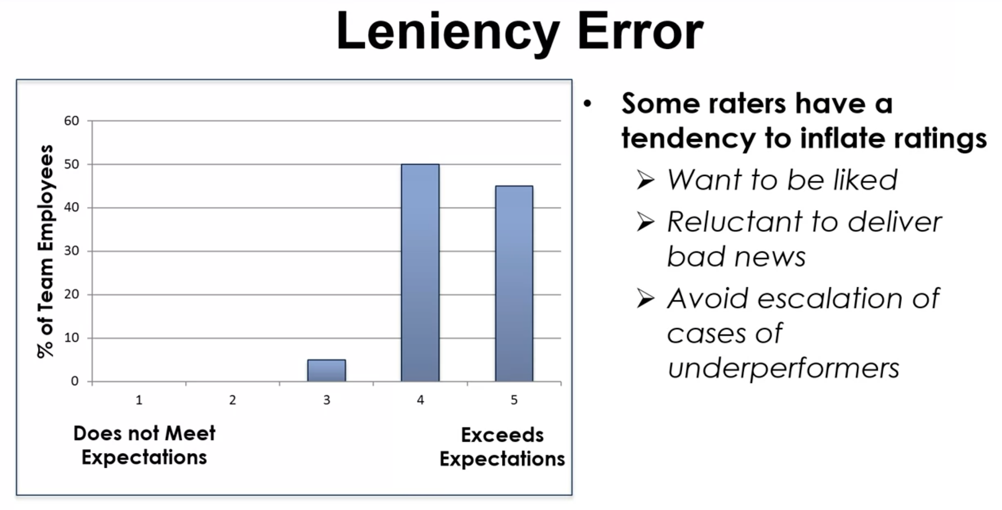

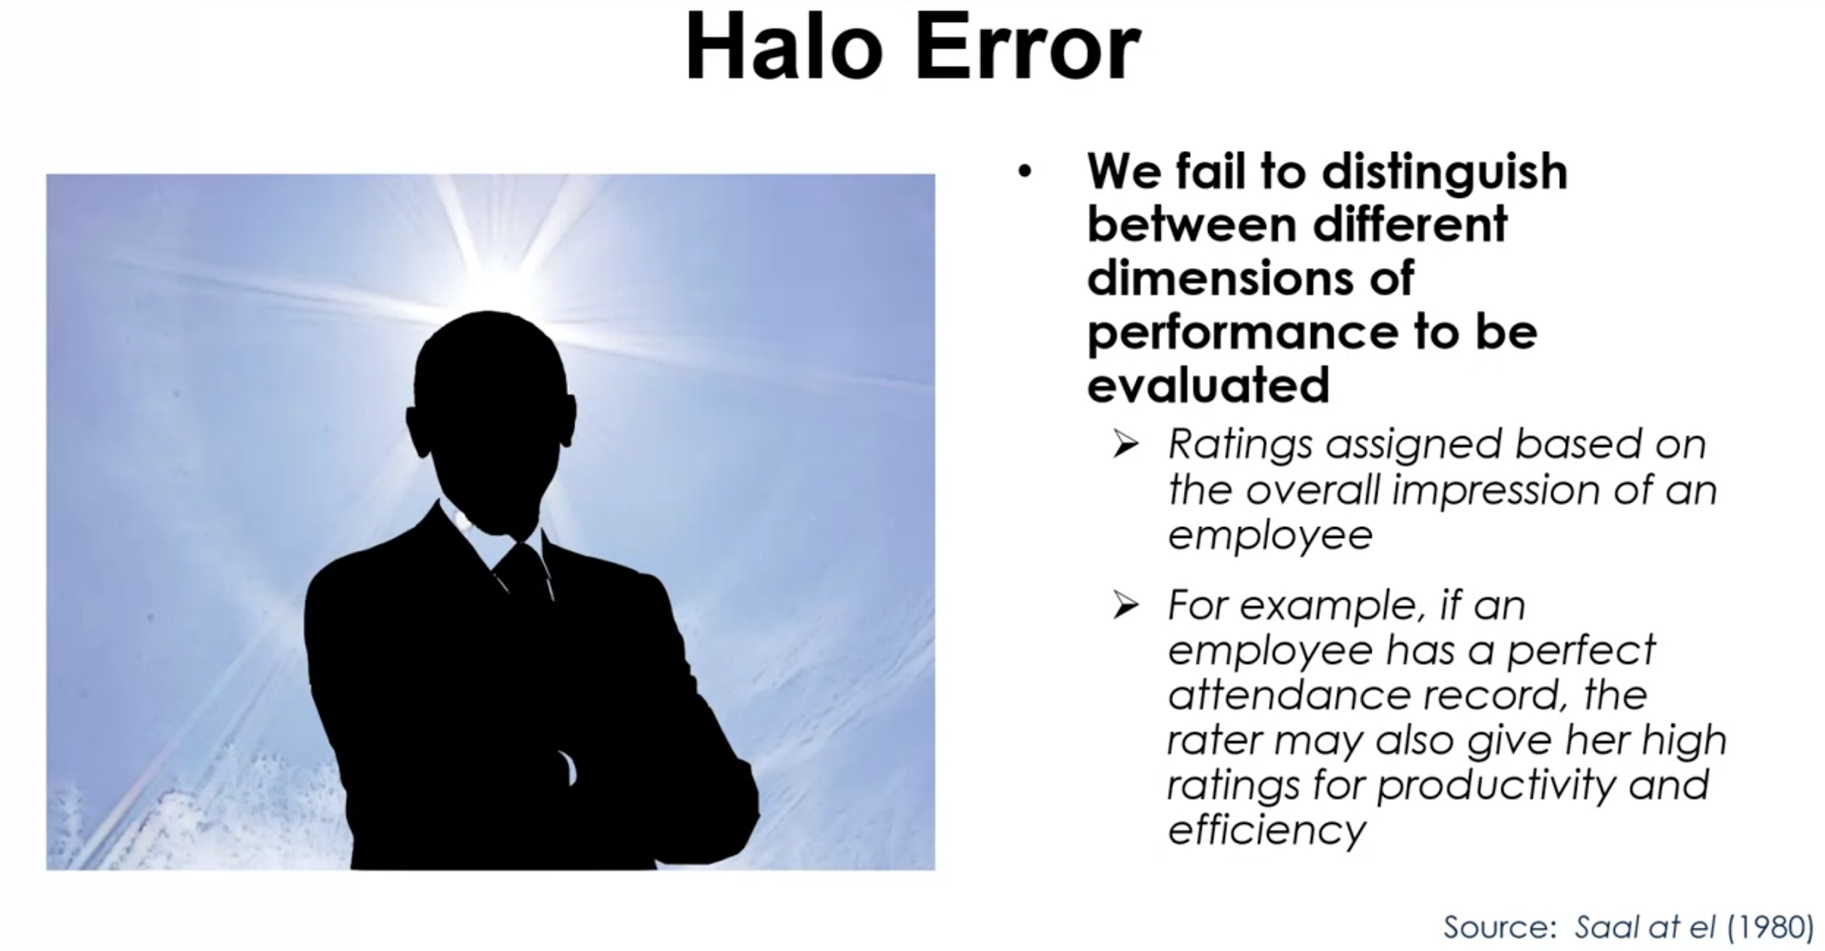

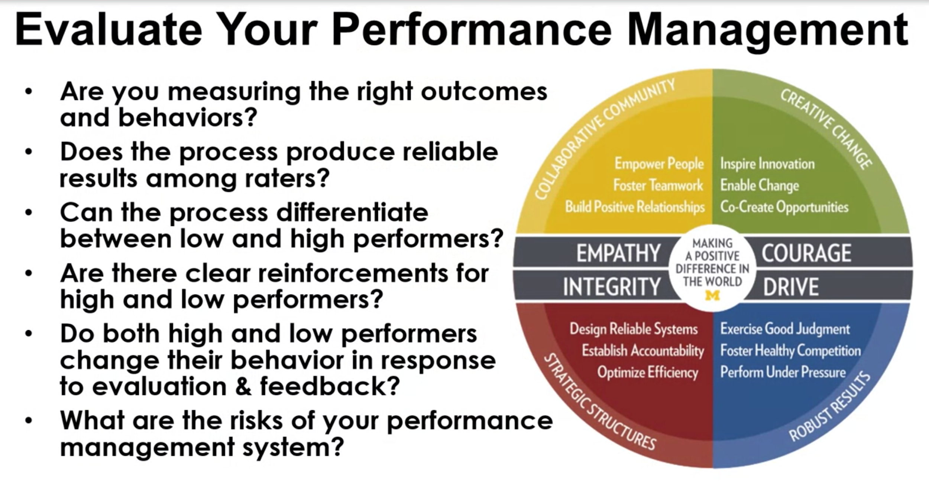

**Week 3**

Discussion on development of strengths and weaknesses, where should you focus and develop?

* Work on your strengths to get even better
* Work on your weaknesses to make them your strengths too

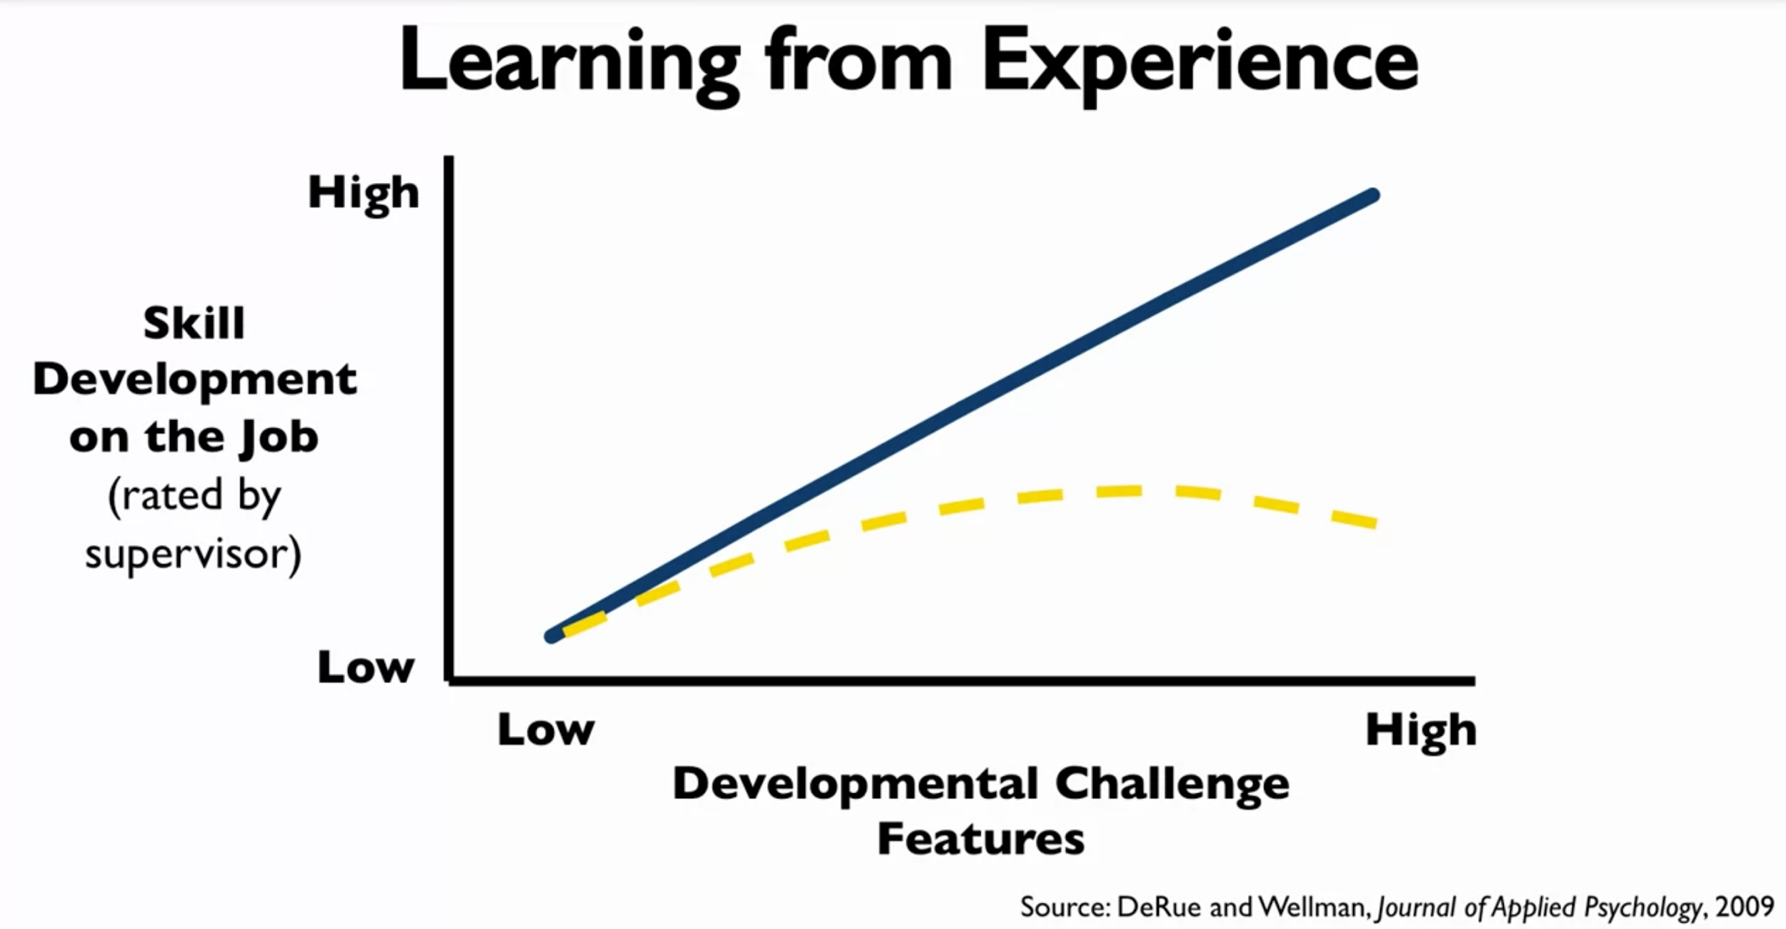

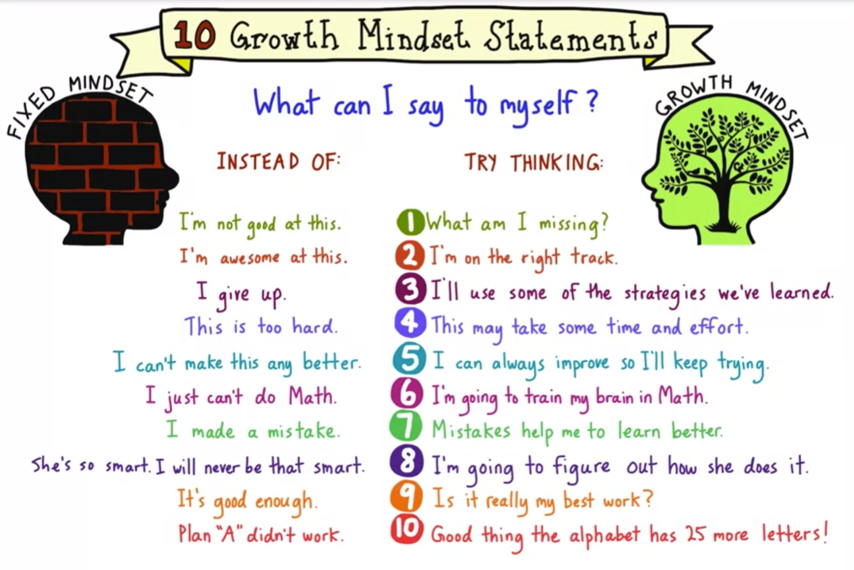

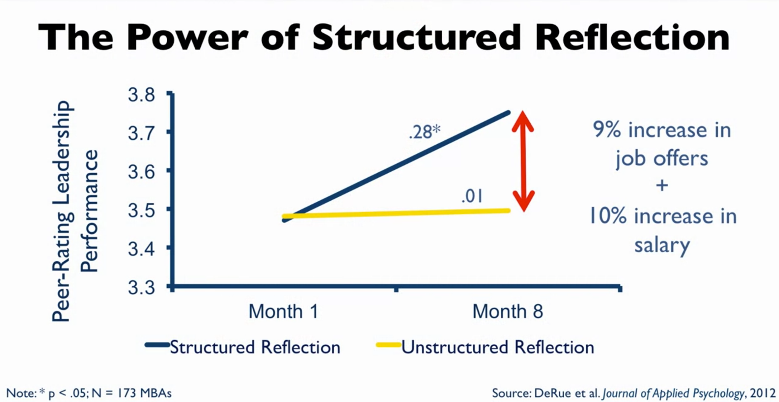

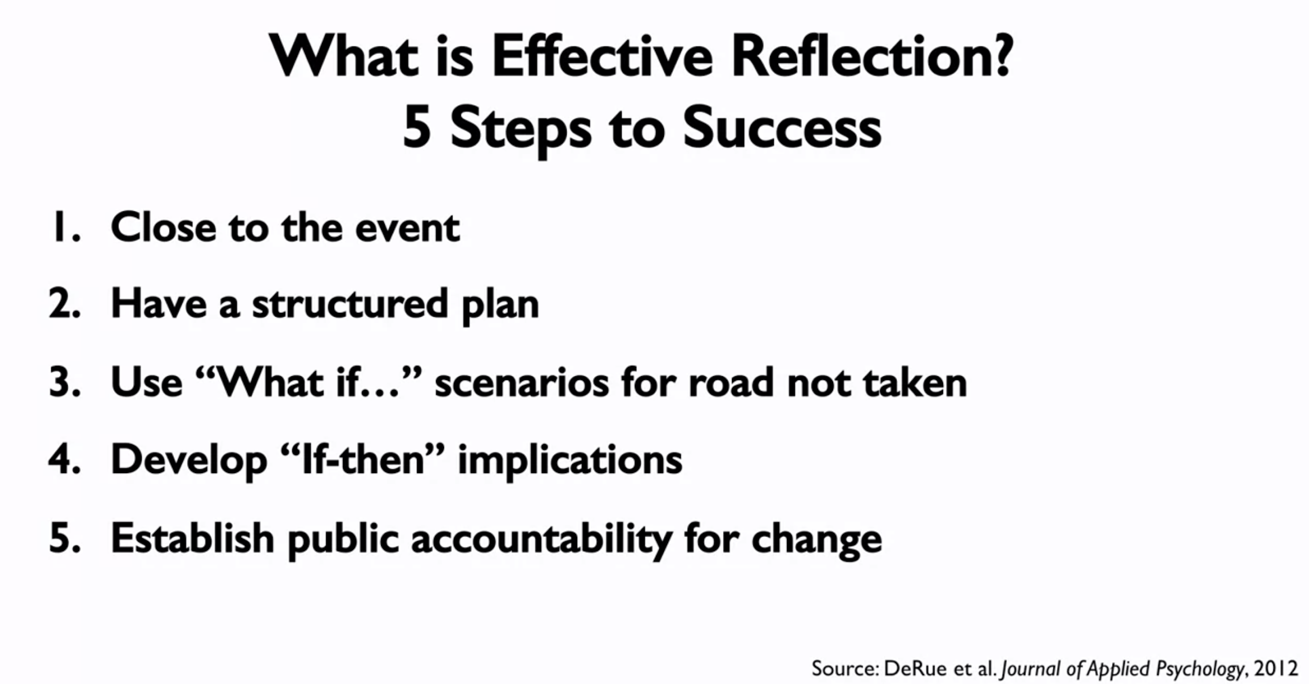

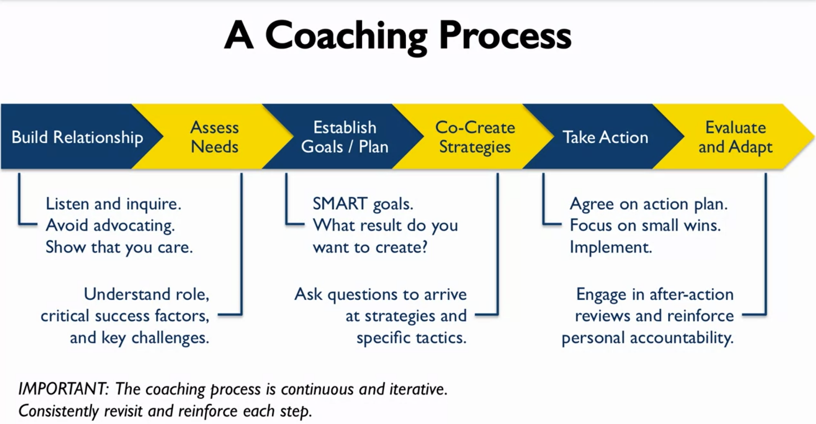

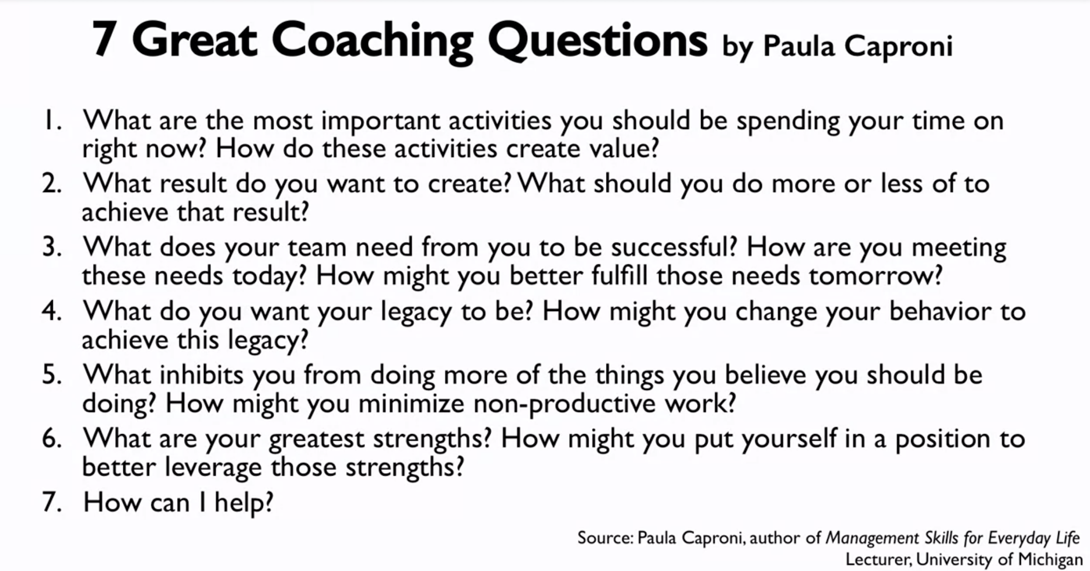

**Week 4**

According to studies, the best way of splitting your time to learn is based on this graph:

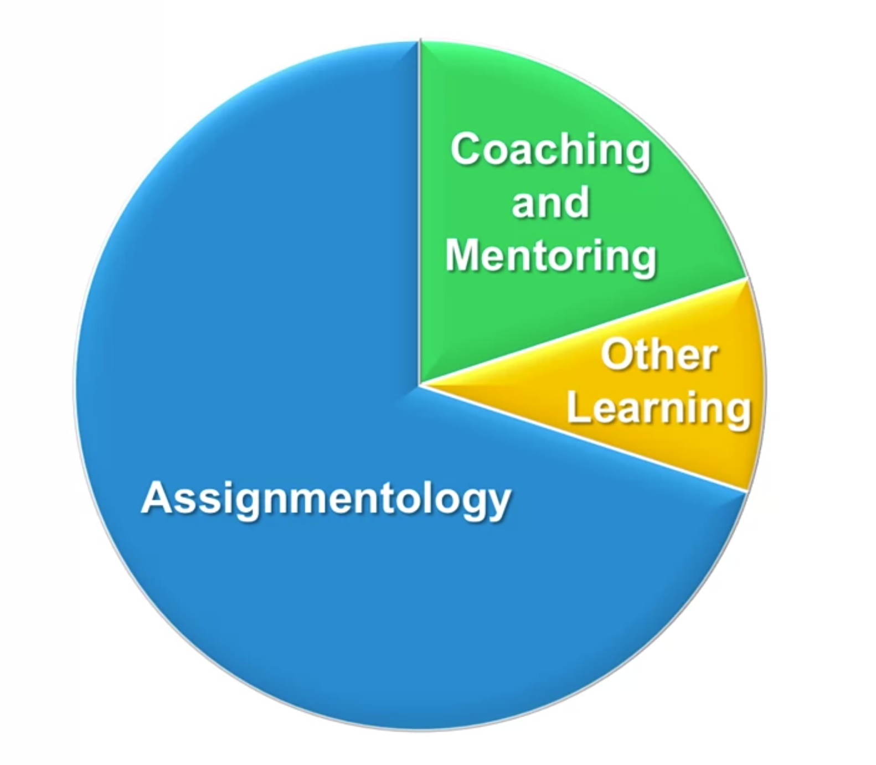

70% in Assignmentology: learn by doing, that means to be assigned on some task and learn during the work on it

20% in Coaching and Mentoring: learn from others, getting some coach and mentoring

10% in Other Learning: speeches, videos, MOOCs

